1. Deploy The custom Image with An Application installed

* Vm with azure AD connect installed

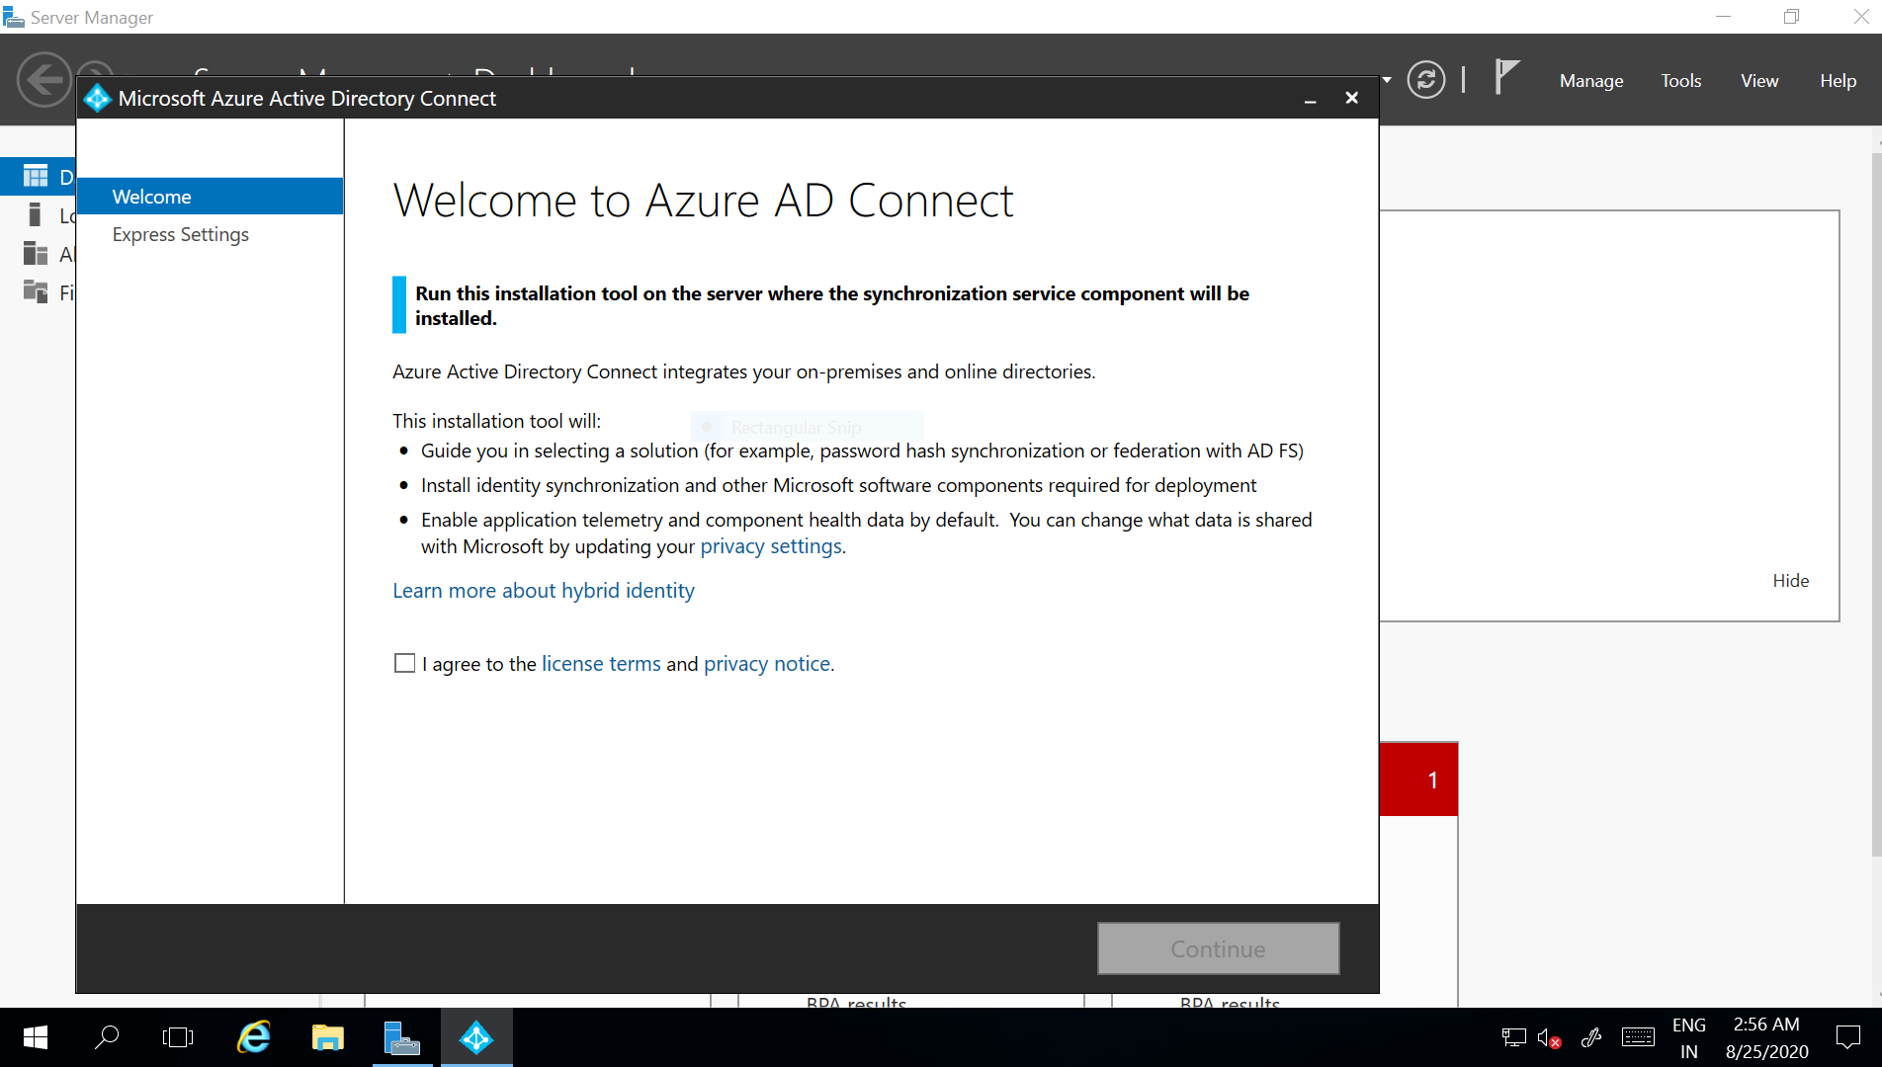

* Sysprep For Vm image deployement and shutting down the existing vm

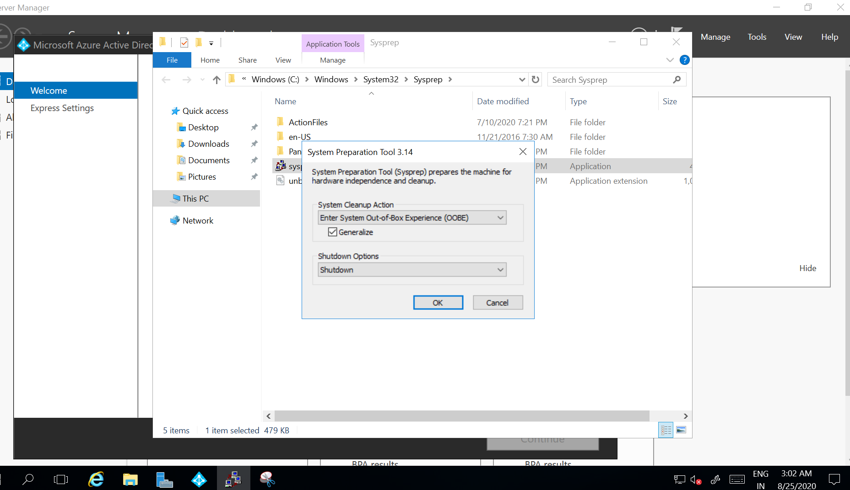

* Created a image by capturing a VM and deleted the existing vm

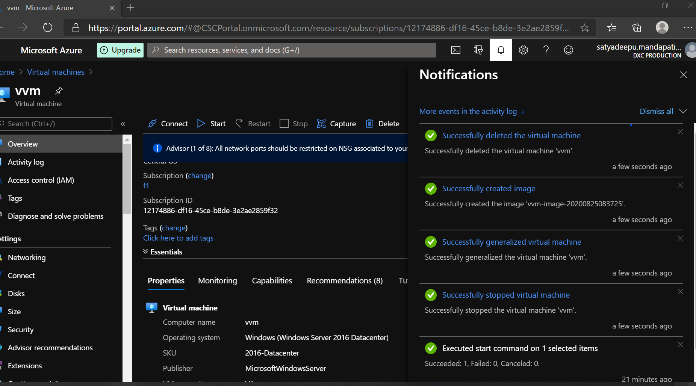

* New Vm with existing Custom VM image

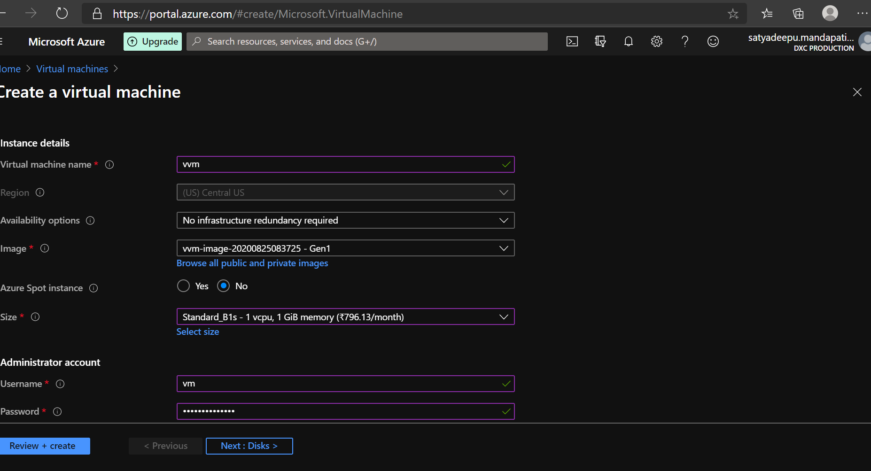

* Checking the installed App in the new VM



**2. Peering two virtual networks from different locations and accesing the VM using private ip**

Vnet peerings between vvm-vnet & vm3-group networks.

Adding peerings in Virtual Networks

* Vvm_vnet peering to vm3_group

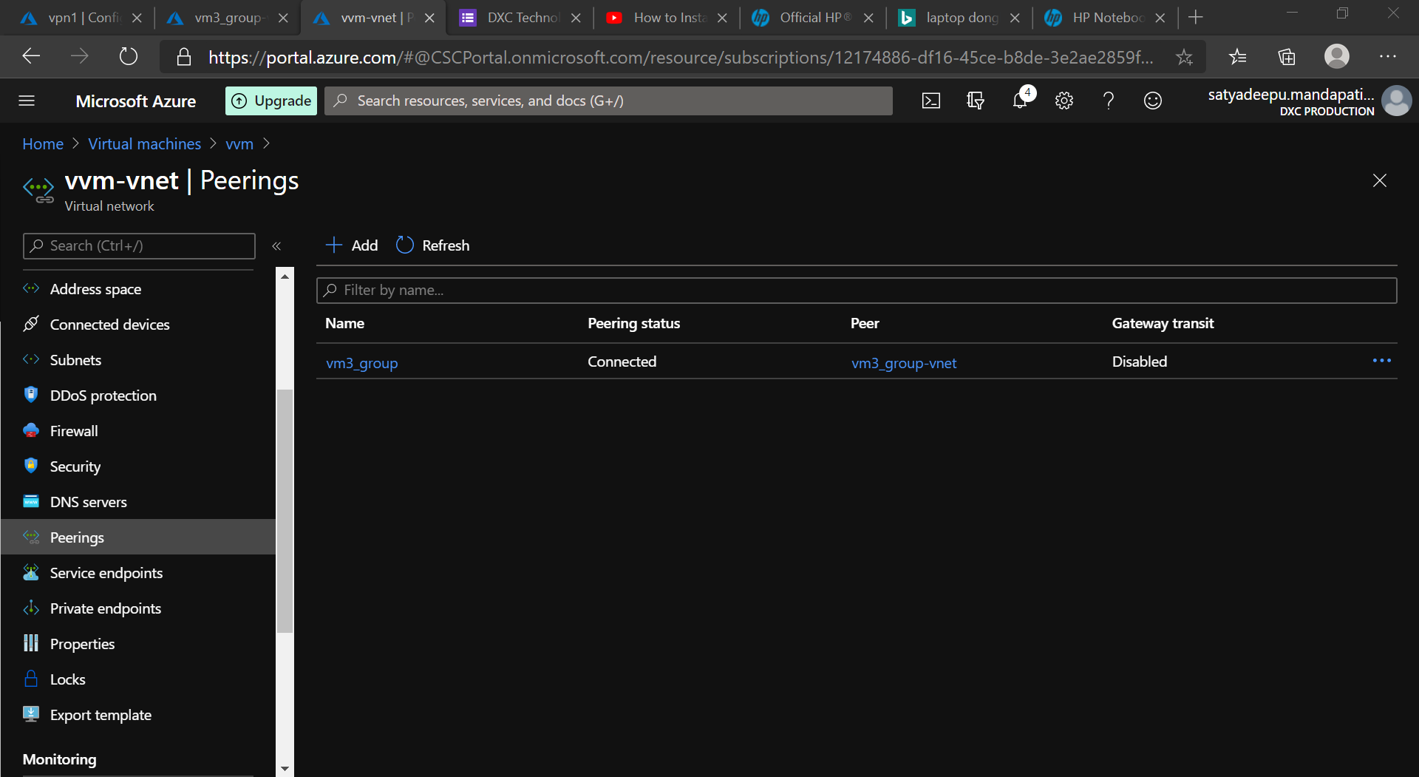

* Vm3_group peering to vvm-vnet

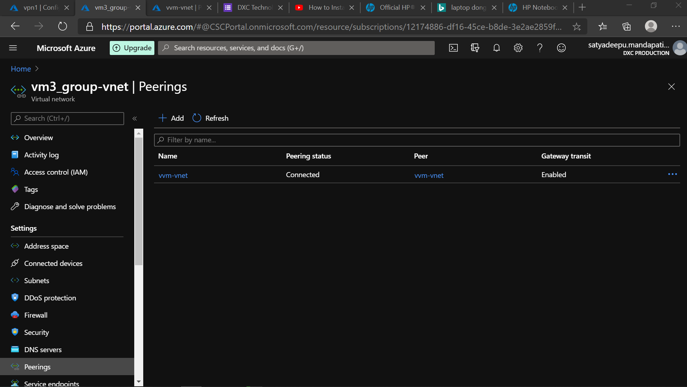

* Vpn gateway in west us location

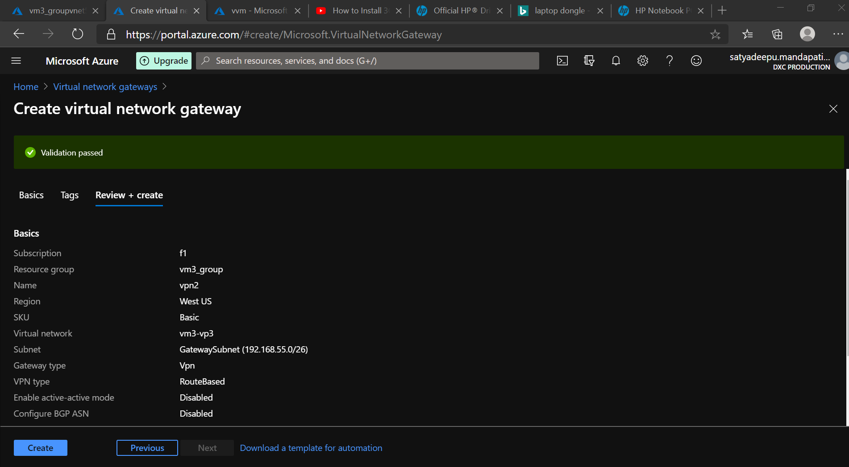

* Configuring Point to site Coonection

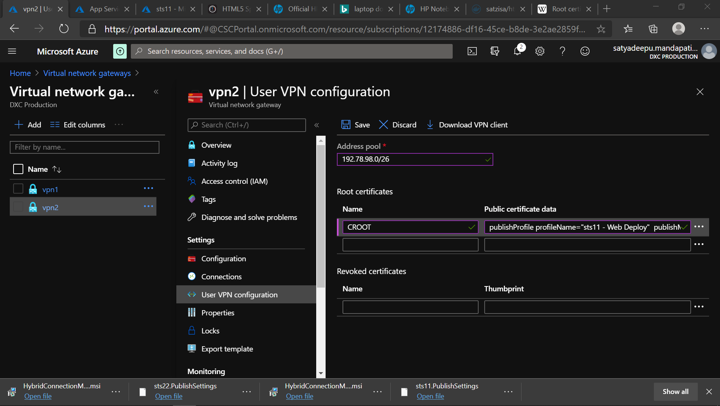

* Creating Root and client Certificates for the vpn and exporting them to the machine

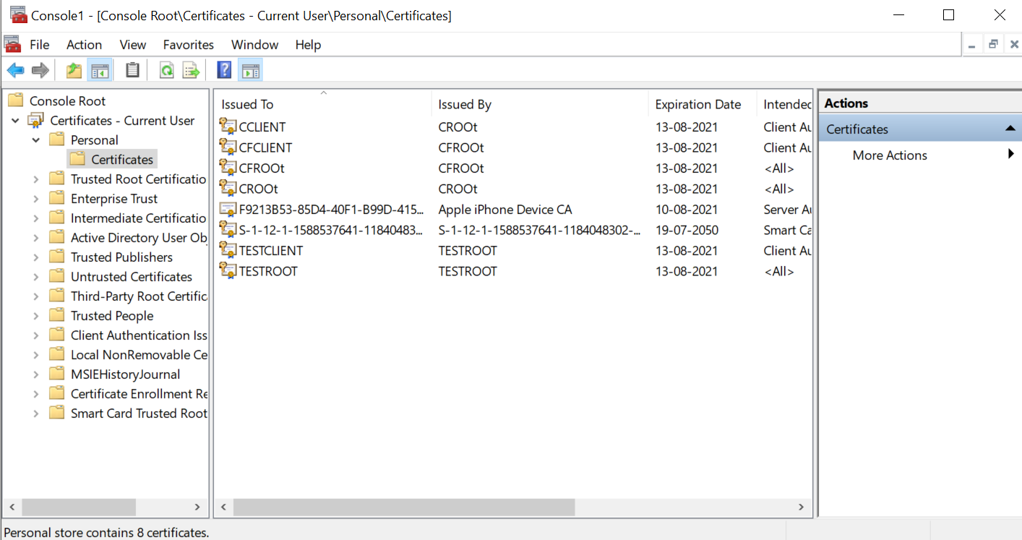

* Connecting from local host(point) to azure datacentre(site) by Downloading the VPN client Agent

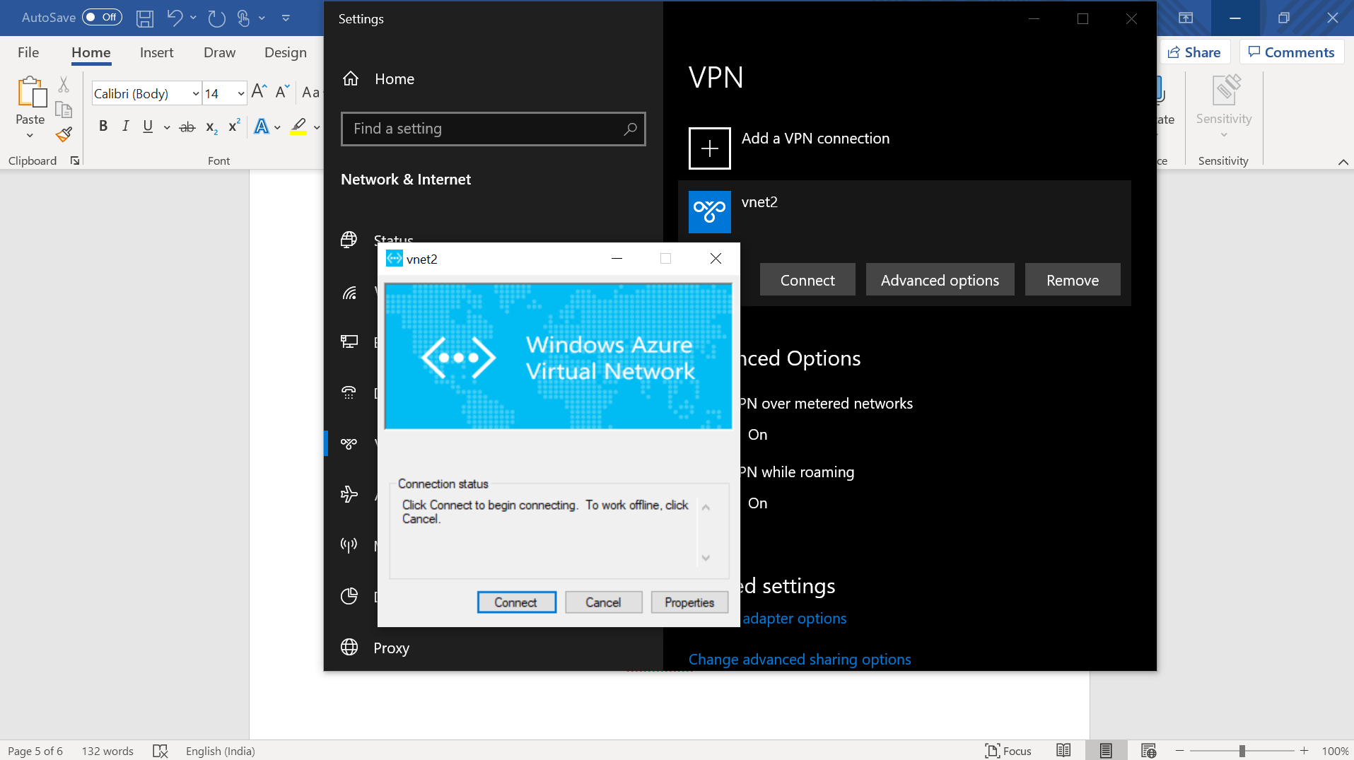

* Accesing the VM using Private Ip of vm after connecting to the vpn client

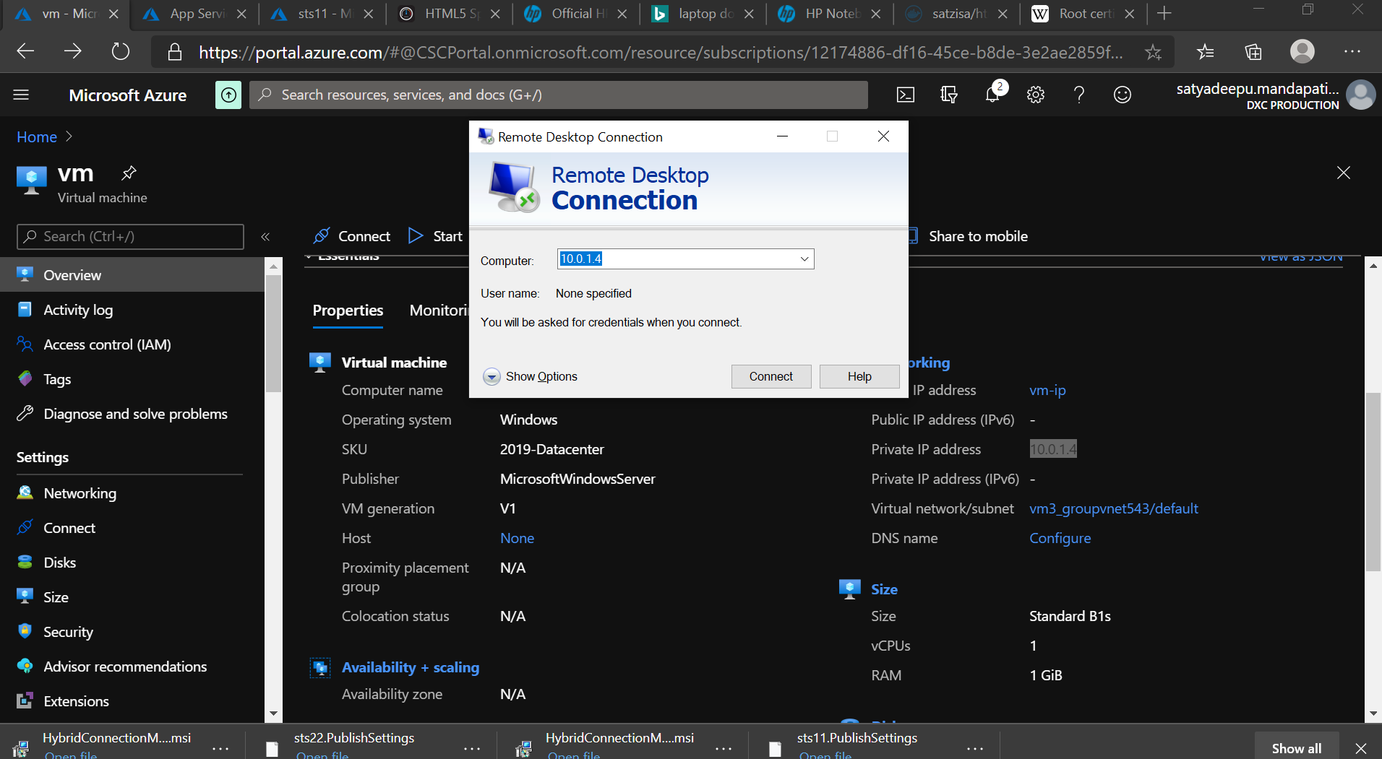

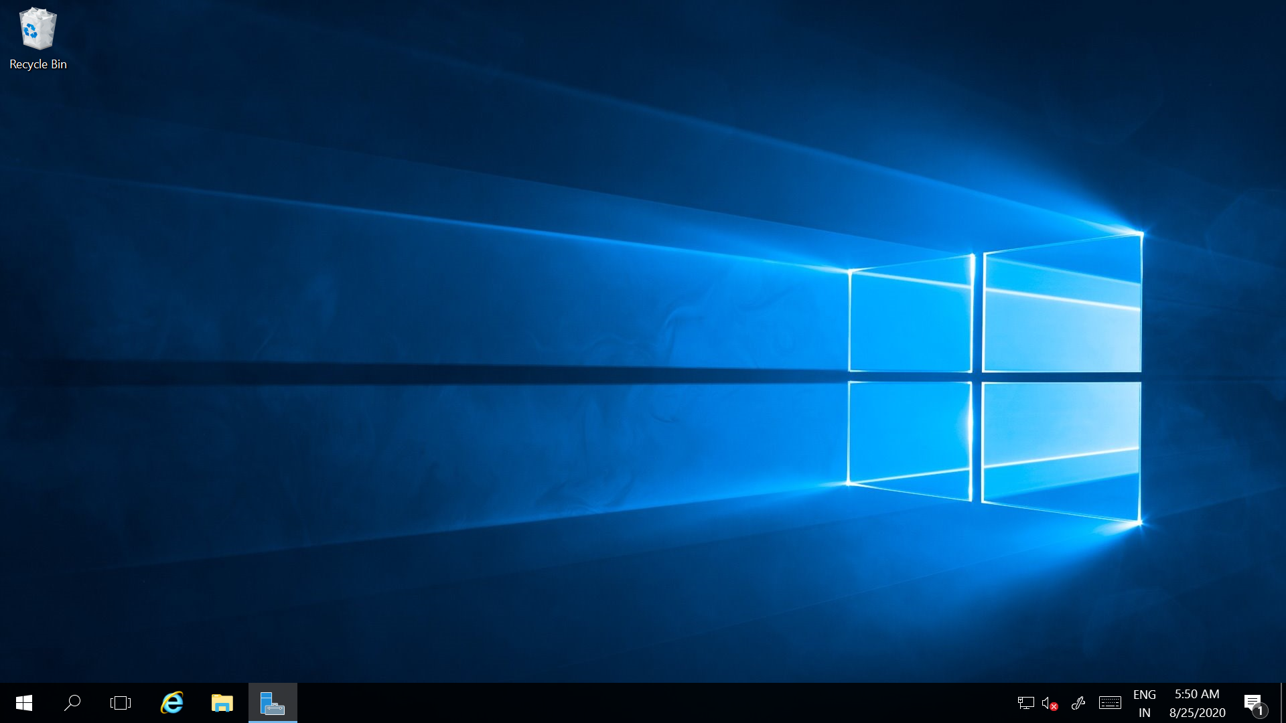

**3.**Creating two web apps and accesing under the traffic manager

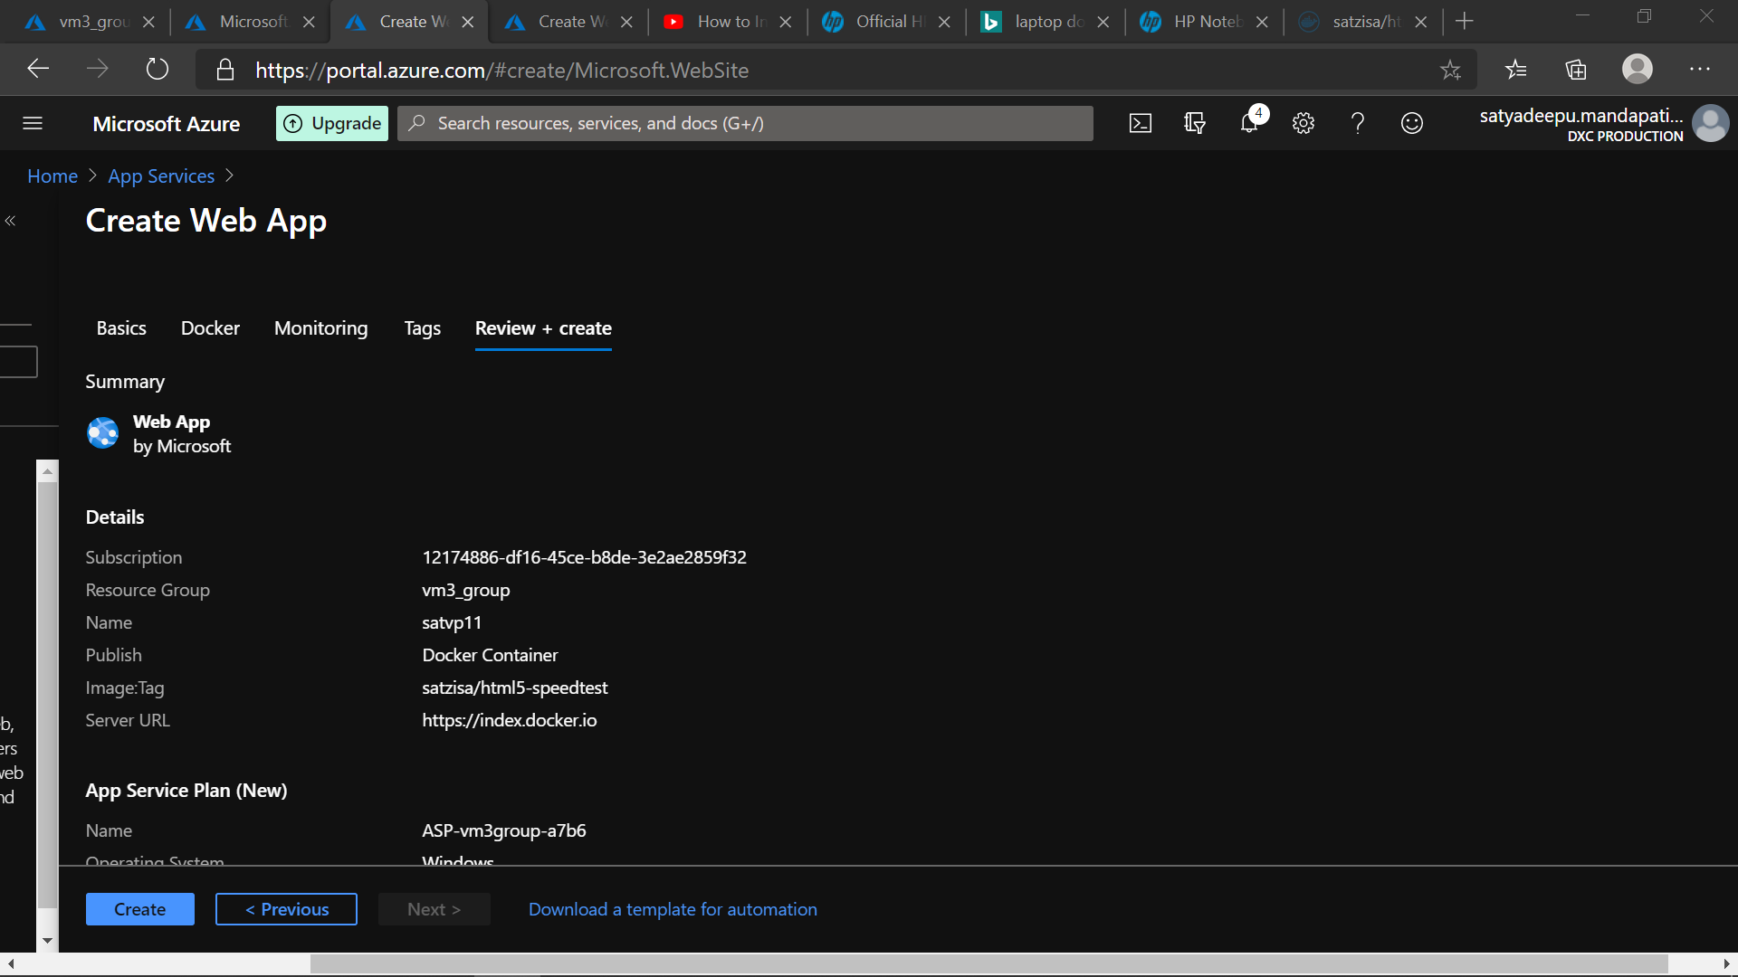

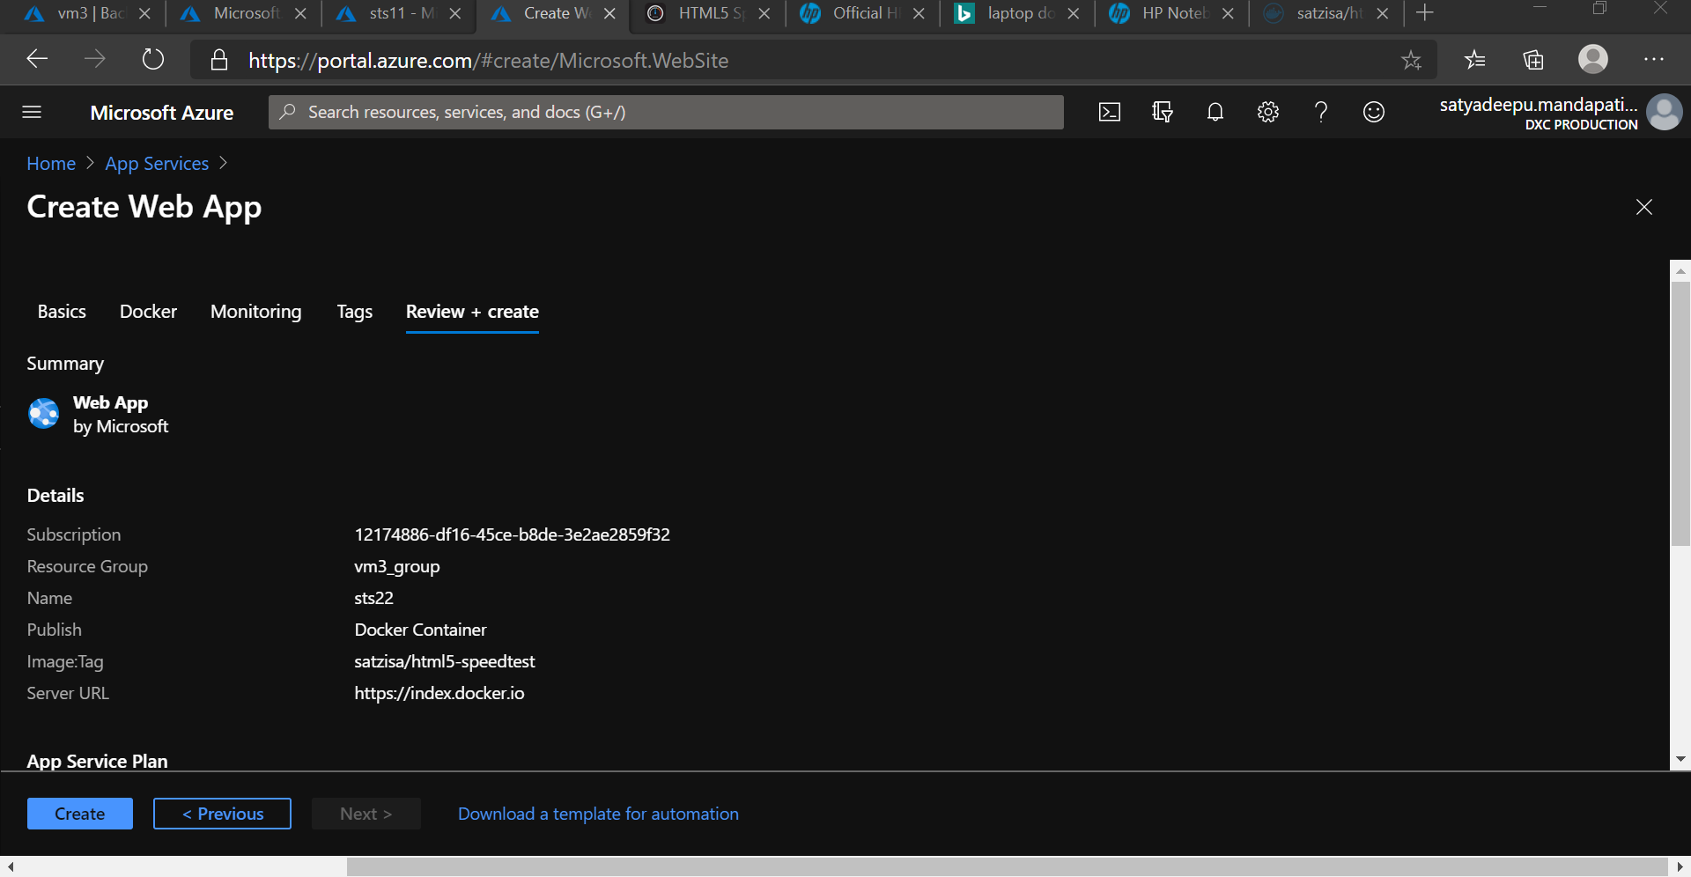

* Setting up a traffic manager

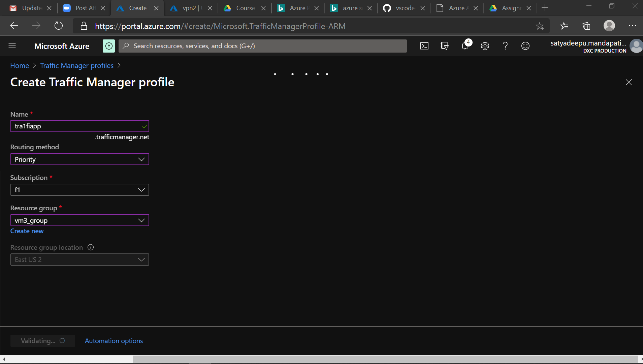

* Configuring Two Traffic endpoints for routing in Traffic manager

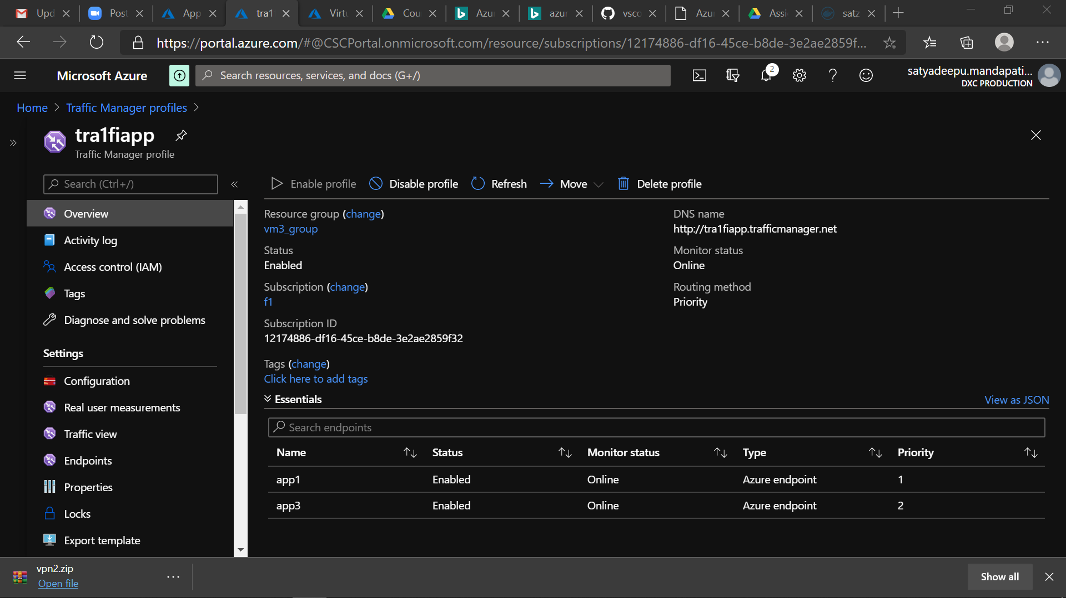

4. Create a Backup solution for the Vm and assign a daily policy to the VM  with 10 days retention period

* Azure Recovery Vault is created for a VM Backup
* Backing up a VM with Retention Policy for a backup taken at every day at 4:30 for 10days

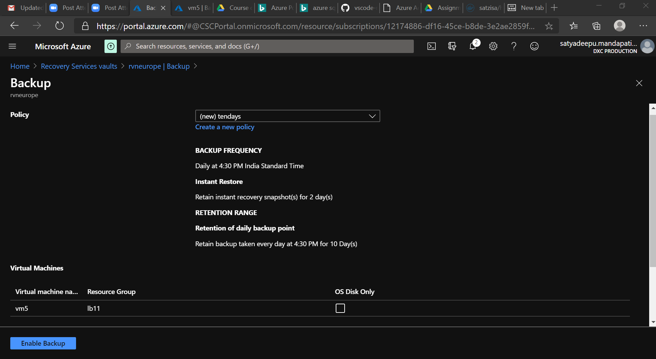

**5.** **Replicate the VM form west us to any location using failover**

* Configuring Disaster Recovery-Replication for a VM from source to a target location

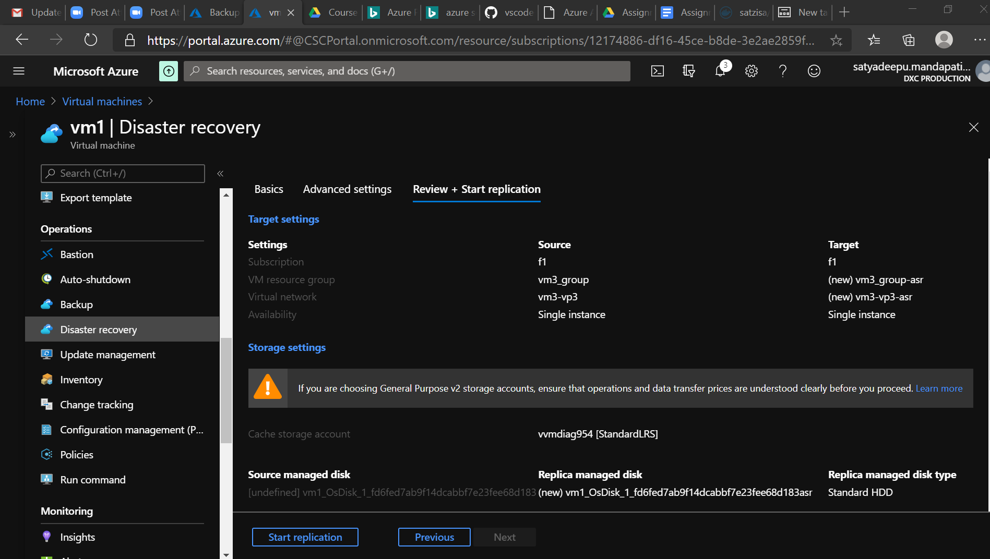

* Replicated items in the Recovery Vault.

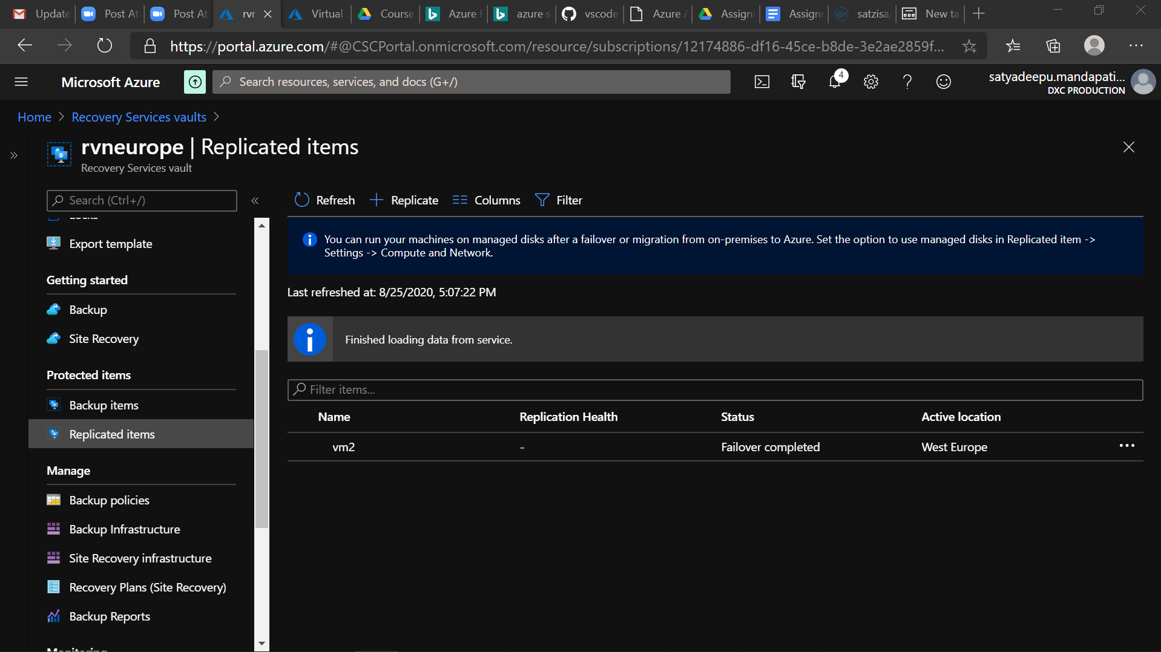

1. on-premises backup using backup agent and exclude test folder from any drive

* On-Premises Backup using a Microsoft Azure Recovery Agent(MARS) in the Local Host
* Using a Recovery Backup credentials to connect the server

NOTE: ” As of its in Company laptop most of the backup configurations and Restore points are inaccessible to connect “.